THE UNIVERSITY OF AZAD JAMMU & KASHMIR, MUZAFFARABAD


COURSE TITLE | I&CT
COURSE CODE | HU-1104
LAB TITLE | EMERGING TECHNOLOGIES
GROUP NUMBER | 10
ROLL NUMBERS | 27, 28, 31
INSTRUCTOR NAME | ENGR. TAHIR ABBASI
SUBMISSION DATE | FEBRUARY 26, 2025

DEPARTMENT OF SOFTWARE ENGINEERING
Contents

Cybersecurity: An Emerging Technology 3
Introduction 3
Definition of Cybersecurity 3
Use Cases and Real-world Applications 3
Data Protection: 3
Network Security: 3
Application Security: 3
Cloud Security: 3
Identity and Access Management (IAM): 3
Benefits 3
Protecting Sensitive Data: 3
Ensuring Business Continuity: 3
Compliance: 3
Challenges 4
Evolving Threat Landscape: 4
Resource Constraints: 4
Skill Shortage: 4
Complexity: 4
Real-World Examples 4
Two-Factor Authentication (2FA): 4
AI and ML in Cybersecurity: 4
Experiment with a Technology Tool 5
Experiment with VirusTotal for Cybersecurity 5
Insights Gained from the Experiment 5
Exploring Email Vulnerabilities: The Second Experiment 6
Insights Gained from the Experiment 6
Key Takeaways: 6
References 7

Cybersecurity: An Emerging Technology

Introduction
We are excited to present our report on cybersecurity. This emerging technology is crucial in today's digital age, and we aim to provide a clear and concise overview of its importance, applications, benefits, and challenges.

Definition of Cybersecurity
Cybersecurity is the practice of protecting systems, networks, and programs from digital attacks. These attacks often aim to access, change, or destroy sensitive information, extort money, or disrupt operations.

Use Cases and Real-world Applications

Data Protection:
Ensuring sensitive data is accessible only to authorized individuals using methods like encryption and access controls.

Network Security:
Protecting networks from unauthorized access and misuse.

Application Security:
Identifying and fixing security vulnerabilities in software applications.

Cloud Security:
Securing data, applications, and infrastructure in cloud computing environments.

Identity and Access Management (IAM):
Ensuring the right individuals have access to the right resources at the right times.

Benefits

Protecting Sensitive Data:
Reduces the risk of data breaches.

Ensuring Business Continuity:
It keeps businesses running smoothly, even during attacks.

Compliance:
Helps organizations meet regulatory requirements.

Challenges

Evolving Threat Landscape:
Cyber threats constantly change.

Resource Constraints:
Maintaining strong security measures can be costly and time-consuming.

Skill Shortage:
There's a lack of skilled cybersecurity professionals.

Complexity:
Modern IT environments are complex, making security implementation challenging.

Real-World Examples

Two-Factor Authentication (2FA):
It means adding an extra layer of security by requiring a second form of verification (e.g., SMS code, authentication app).

AI and ML in Cybersecurity:
Companies like CrowdStrike use Artificial Intelligence (AI) and Machine Learning (ML) to detect and respond to threats. They analyze large amounts of data to identify unusual activities and predict potential attacks in real time, enabling quick and effective responses. (Crowdstrike, n.d.)

Experiment with a Technology Tool

Experiment with VirusTotal for Cybersecurity
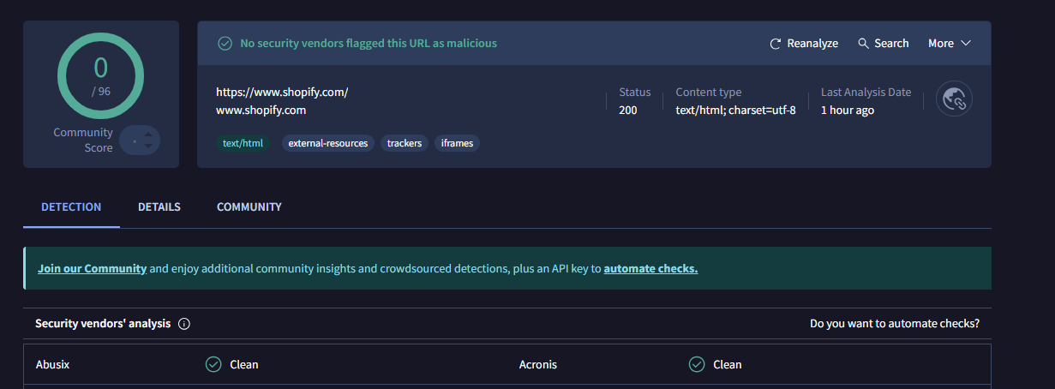

Figure 1: Screenshot showing the data for a website.

Insights Gained from the Experiment

In this experiment, we used VirusTotal, an online service that checks files and websites for malicious content. By entering the URL for Shopify, we ran a thorough scan using multiple antivirus engines. The results showed that the site was safe and didn’t have any hidden threats like viruses or malware.
From this tool, we learned how easy it is to assess the safety of websites before visiting them. VirusTotal compiles results from various antivirus programs to give a clear picture of any potential risks. This hands-on experience showed us the importance of staying proactive about cybersecurity in today's digital world. By regularly checking files and URLs, we can avoid malware infections and keep our systems safe.
This experiment emphasized the practical use of VirusTotal for protecting both personal and business data from cyber threats. It highlighted how vital it is to use online tools to maintain cybersecurity and keep our information safe from ever-present digital dangers.

Exploring Email Vulnerabilities: The Second Experiment
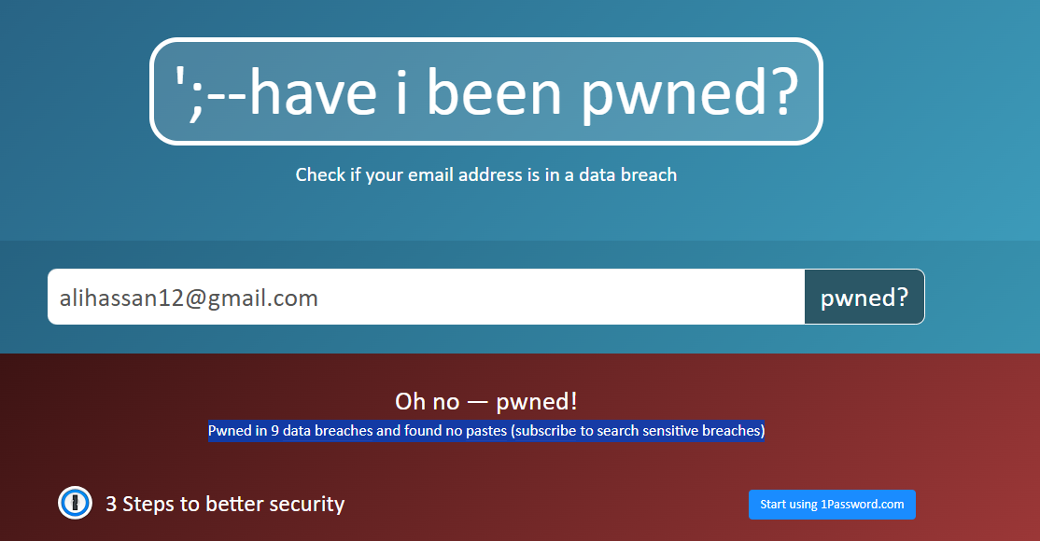

Figure 2: Screenshot showing the results of the search.

Insights Gained from the Experiment

In this second experiment, we used a software called "Have I Been Pwned?", and we discovered that our test email was involved in 9 data breaches. This indicates that the email's associated data has been exposed multiple times across different security incidents. However, no pastes were found, which suggests that the compromised data has not been publicly shared on paste sites.

Key Takeaways:
- Data Breaches: The email has been compromised multiple times, emphasizing the importance of monitoring email security and changing passwords regularly.
- Pastes Absence: No pastes found indicate that the breached data hasn't been widely distributed or made publicly available, which is a slightly positive aspect in terms of data exposure.

References

(n.d.). Retrieved from Crowdstrike: https://www.crowdstrike.com/

